Please read this brief carefully before completing the role

JOB: RETAILER X Engaging with customers & handing out ‘XXXX” coupons in-store £15/hr
RETAILER: Insert retailer name
PRODUCTS: Insert name of brand / products to check

COMPLETION: As per the dates on the role you have booked onto
PAY: £15 per hour to a MAX of 2hours
EXPENSES: NONE

PLEASE MAKE SURE YOUR ADDRESS IS CORRECT ON YOUR PROFILE AS THIS IS WHERE THE COUPONS WILL BE SENT TO.

OVERVIEW / BACKGROUND TO THE CALL
We're really excited to share with you that we've launched XXXXX in XXXX.
This is a great job and we really need your support on our journey to spread the word to store colleagues & customers to encourage them to try them.

You will be sent XXX coupons for each store visit. These are ‘try me free’ coupons
There are XX coupons for the store colleagues, and XX coupons for you to hand out to customers in-store during your 2 hours.

We want you to go into store, speak to a colleague to let them know that you’re there to hand out coupons to customers which enables them to try the products for free and therefore drive the stores’ sales, and also to give some coupons to the staff so that they can trial the products too.
You’re here representing BRAND X.

Please note that coupons will be dispatched to your home address so please check your details are up to date on your profile so that they arrive safely. If you unbook after coupons have been dispatched (Friday before calls go live) then you will be responsible for returning these to XXXXX at your own cost.

WHAT DOES A GOOD JOB LOOK LIKE:
Enaging with customers and talking to them about XXXX and giving them a coupon to try it for free
Selling through as much XXXX stock in the time that you are in-store

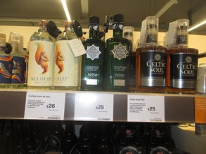
LOCATION IN-STORE: XXXXXX Fixture

PRODUCTS TO CHECK:
INSERT table here with retailer code / product name / pack size / weight / expected retail price

REQUIREMENTS OF THE ROLE:
- AHEAD of the role - Check your address is correct on the system

Once you have received the vouchers visit the store between 1100-1400 on day of your choice
INSERT IMAGE OF FIXTURE IN-STORE, ideally of what a good job looks like so workers can easily identify the fixture where they will find the product
- Go into store & sign in
- Head to the XXXX fixture and check the availability of the XXXXX
- If there is stock speak to a colleague to let them know that you’re there to hand out coupons to customers which enables them to try the products for free and therefore drive the stores’ sales, and also to give XX coupons to the staff so that they can trial the products too.
The activity will be agreed locally with the store.
- Agree with the colleague the best place to speak to customers – ideally in high traffic areas / near the fixture.
- The vouchers are for XXXXX – these will scan through the till meaning that the product will then be XXX

Hand out vouchers to customers for max of 2 hours
- Answer questions and upload requested images

HAVE YOUR CAKE AND EAT IT!

Fitbakes we believe that eating healthy doesn't have to be boring! We've found that using the best ingredients nature has to offer makes the best snacks, and we've got many delicious creations for you to look forward to.
INSERT IMAGE OF PRODUCT TO SELL

INSERT DETAILS OF KEY FEATURES & BENEFITS OF THE PRODUCT
- Why should the store support this?
- Why should customers try it
- - What’s great about it?

Overcoming objections – give them some answers to some FAQs that may be asked
Remember – they are there to sell your range so give them some key facts to help them do this

We also love numbers! We know, they can be boring, but that's why we take care of it so you don't have to think about it when you eat your snack.

US VS. THEM CRUNCH
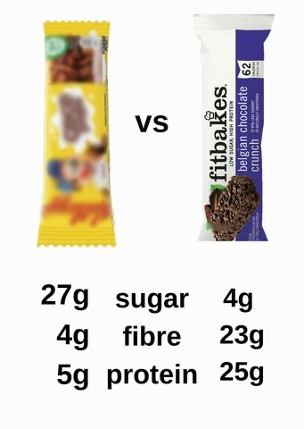

SO W HERE’ S THE SUG AR?

In short, we use erythritol to make Fitbakes delightfully sweet without all the calories of regular cake. Erythritol, which though it has a rather scientific-sounding name, is actually a natural sweetener found in fruits like pears, watermelons and grapes. Though it’s technically a sugar alcohol, it's unlike the others because erythritol doesn’t affect blood glucose or cause bloating.
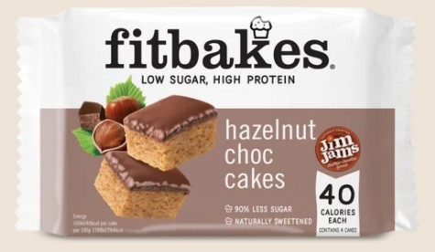
You are promoting Fitbakes Hazelnut Chocolate 30g (89980872)

chocolate spread. Yummy!
Do you know that famous hazelnut chocolate spread that you love? We managed to make a cake topped with it, with 97% less sugar! Low Sugar Hazelnut Spread Cakes, are a light vanilla sponge with JIM JAM'S low sugar hazelnut

  - 🍫😋 GREAT TASTE – Enjoy your favourite chocolate hazelnut spread treats without the guilt!
  - 🧬🏋♂ HIGH PROTEIN – These high protein snacks are the perfect for upping your protein intake on the go or chilling with a cuppa.
  - 👩🍳🏃♀ LOW SUGAR – 90% less sugar.
  - ✅🧗♂ HEALTHY ALTERNATIVE – Get your chocolate fix in these high protein low sugar hazelnut chocolate cake bars.
  - 🌱❤ VEGETARIAN – All Fitbakes treats are suitable for vegetarians.

REPORTING QUESTIONS TO COMPLETE AS PART OF YOUR TIMESHEET
- What date did you visit the store?
- What time did you visit / sign in? (remember it needs to be between 1100-1400 when stores are busiest)
- Photo of the fixture to show XXXX on entry
- Was XXXX available on Entry?
- How many units of XXX were available on entry?
- Was there a price ticket (SEL) XXXX ?
- What interventions have you made in-store on XXXX
- Who did you speak to in-store? Name & position of contact
- Did you give the colleague 1XX coupons for them to share with staff to try the products for free?
- If NO please give details
- Where in-store did you agree with them you could hand out the coupons to customers
- If OTHER or N/A please give full details & call CONTACT NAME / NUMBER for further advice
- How many coupons have you handed out to customers?
- How many coupons have you used to try the product yourself?
- How many units of XXXXX were available on exit?
- Photo of the fixture to show XXXXX on exit
- What have you done with any left over coupons?
- Have you thanked the store for their support?
- Have you shared with them feedback from customers?
- Please share with us what anecdotal feedback customers gave you when handing out coupons? Were they receptive? Did they think it was a good idea? Did they like the sound of the product?
- In your opinion should this store be used for couponing activity again?
- If NO, please tell us why
- Any other feedback or comments for us about this call?
- What time did you leave / sign out of the store?
- Please upload a photo of the outside of the store

PLEASE SUBMIT YOUR TIMESHEET ON THE DAY YOU HAVE COMPLETED THE CALL
Once we have verified this, you will be paid on the next payroll according to your preferences.
Thanks for being a part of the revolution! Don't forget to tell your friends/family about redwigwam & XXXXXX

Many thanks,
The redwigwam & XXXXX Team

PLEASE DELETE THIS SECTION BEFORE SAVING YOUR FILE AS A PDF (remember to reduce the images as max file size is 5MB)
To get your job loaded & live please log into your account https://hirer.redwigwam.com/login/
On your dashboard go to JOBS – ADD A JOB, Select Sector – RETAIL, Select Job Type – BRAND AMBASSADOR, Select template job - Retail - Couponing &/or active selling in-store - £11/hour
You will then need to update the job according to your requirement and also ensure you amend the products / pricing in the reporting section too from XXXXs / ABC.
If you need help then please pop onto live chat or email catherine@redwigwam.com

